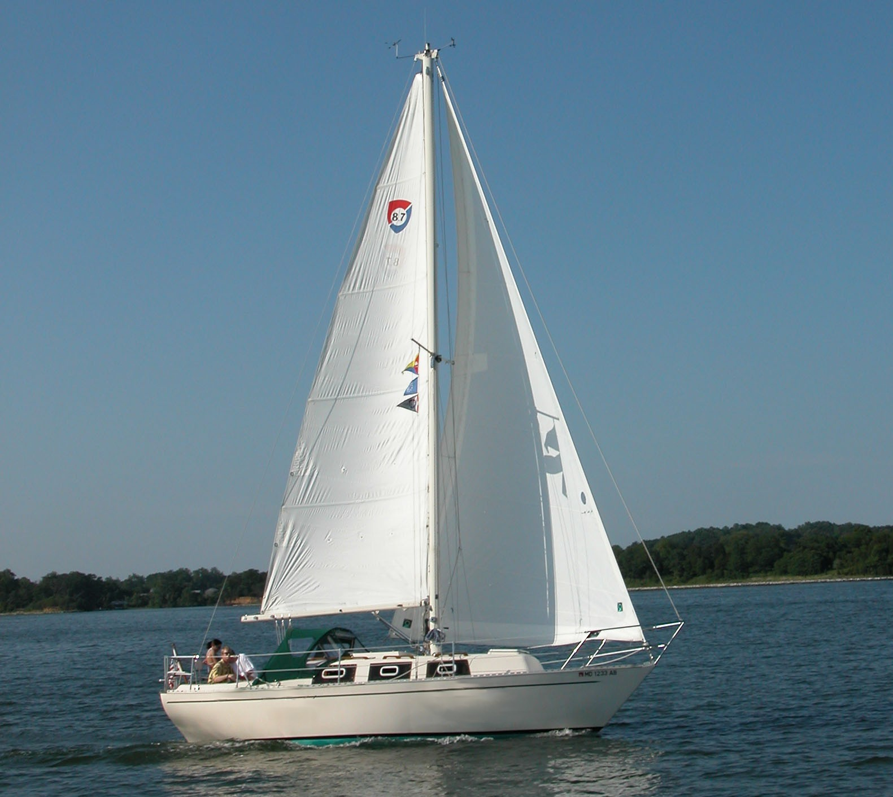

OWNER’S MANUAL

FULL SAIL

1977 COLUMBIA 8.7

Full Sail Overview

Full Sail is a 1976 Columbia 8.7 sloop. The purpose of this document is to update and replace the original owner’s manual that came with this boat. Over the past twenty-four years there have been many changes made to Full Sail. Most of these changes are improvements, but regardless they have rendered the original manual incomplete and inaccurate. Time has also deteriorated the manual to the point where several pages were no longer legible. The result is this document, which attempts to cover all the major systems of Full Sail.

- Deck Systems
- Diesel Engine
- Electrical Systems
- Electronics
- Below the Waterline
- Cabin Systems

Deck Systems Overview
Full Sail’s deck is the working platform for this sailboat. Since Full Sail has been single-handed most of the time, the deck systems are relatively simple and straightforward. Steering is by tiller. This is much simpler and more reliable than a wheel steering. The tiller also rises out of the way when at anchor or dockside, allowing full use of the cockpit. The tiller has also allowed me to install an Autohelm ST4000/T autopilot I call Captain Ron. Wheel steering either limits you to an under-performing autopilot that attaches to the wheel or a very expensive and complex one that attaches directly to the rudderstock. The relatively inexpensive and simple ST4000/T can steer Full Sail in almost any condition and point of sail.
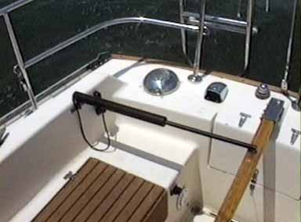

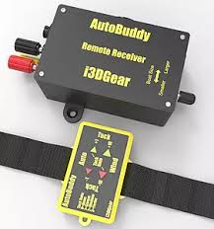 | The addition of an AutoBuddy wireless remote system by I3dgear allows the helmsman to control the ST4000 from a wrist band controller any place on the boat. While at the same time allowing handsfree control with ease.

The original deck systems delivered with Full Sail have been changed very little over the years. A halyard winch was added for the mainsail (the Jib halyard winch was standard) and slab reefing for two reef points, but found it unnecessary to implement any major upgrades on deck. The basic deck plan is depicted in the diagram below from the original owner’s manual. In 2021 I added a deck plate from Garhauer hardware along with Spinlock deck organizer and a used clutch to allow the mainsheet running rigging to be handled from the cockpit.

Standing Rigging
The standing rigging includes the mast, boom and wire rope stays and shrouds that support the mast. The mast is a single aluminum extrusion. The masthead contains four sheaves for the two halyards (main and jib) and a platform for the Windex, masthead tricolor/anchor light and the Autohelm wind instrument sending unit. The mast has a single full length extruded sail track, single spreaders and is stepped on the deck in an aluminum shoe. All mast wiring exits the mast on the port side and terminates in Aqua Signal through deck connectors.
Full Sail has single fore and backstays, single upper shrouds, and single lower middle and single forward shrouds. The stays and shrouds are 7/32” 7x7 stainless wire rope. Navtec turnbuckles on the backstay and each of the six shrouds are used to tune the rigging. A Merrimam turnbuckle was added to the forestay. The original rigging did not have a turnbuckle in the bow, which made tuning the rigging more difficult, so this turnbuckle was added some time ago. The wire rope is the original standing rigging on Full Sail.
The boom attaches to the mast via a gooseneck, which is secured within the sail track on the mast.
The rig should be re-tuned every spring, any time the mast is re-stepped or after a prolonged sail in apparent winds greater than 20 knots. Tuning can be performed in four steps.
- Set up the mast in column. Secure all shrouds and stays with minimal tension. Adjust to insure the mast has no visible bend to either side.
- Center the masthead over the deck. Using the jib and main halyard adjust the shroud tension to ensure that the halyard distance to points opposite each other on the toe rail are the same. At this point you are ready for a trial sail.
- Adjust the shroud tension under sail to keep the mast in column. On a day of moderate sailing (true wind twelve to fifteen knots) start sailing on a close reach. Sighting up the mast to determine if there is any fall-off of the masthead from the straight column. If so adjust the upper and middle lower shrouds to bring the mast back into column. Bring the boat onto the opposite tack and adjust for any out of column condition. Tack back once more and verify that the mast is still in column. Secure the upper and middle lower shroud turnbuckles with cotter pins.
- Adjust fore and back stay tension to achieve slight mast bend. On the same trip, check for mast bend. The mast should have a slight, smooth aft bend. Adjust the fore and backstays and the lower forward shroud to provide the bend with no bow (forward bend) in the mast. You want just enough bend to allow you to flatten the mainsail by fully tensioning the mainsheet and boom vang. If you adjust the lower forward shrouds, be sure you make equal adjustments on both shrouds to keep the mast in column. Check when you have achieved proper mast bend and secure all turnbuckles with cotter pins.

Running Rigging
The running rigging consists of halyards, sheets, tackle and winches necessary to trim and control the mainsail and jibs.

Halyards
Full Sail has three external halyards, Main, Jib, and Spinnaker. The main halyard runs through the starboard masthead sheaves and is tensioned with the halyard winch on the starboard side of the mast. The jib halyard runs through the port masthead sheaves and is tensioned by the halyard winch on the port side of the mast. The Spinnaker halyard runs through a block at the front of the masthead. The jib and main halyards are attached to the sail with a headboard shackle. The spinnaker halyard is attached to the sail with a snap shackle.

Sheets
The mainsheet is 3/8” double braid line that runs from the becket on the double fiddle block on the traveler through each of the three blocks on the boom the cam cleat on the traveler. The mainsheet provides a 6:1 purchase.

Full Sail is equipped with a rigid boom vang. The vang has a 16:1 purchase.

On the wind the sheets can be led through the fairlead blocks on the Genoa track on deck to the sheet winches on the cockpit coaming. Off the wind the sheets can lead through snatch blocks attached to the toe-rail.

Whisker Pole
In 2017 a mast mounted whisker pole was installed by “The Rigging Company”, it’s use is simple to control and allows safe downwind control of the Genoa. To deploy roll in the Genoa, unclip the pole head from the retainer and position the pole to grab Genoa sheet line within the knotted section. Now using the pole twist lock tighten the pole and attach a retainer line to the pole to insure the forces stay low. Unroll the Genoa and using the pole height loop on the mast bring it to relativity horizonal position and cleat the retaining line to toe rail.

Sails
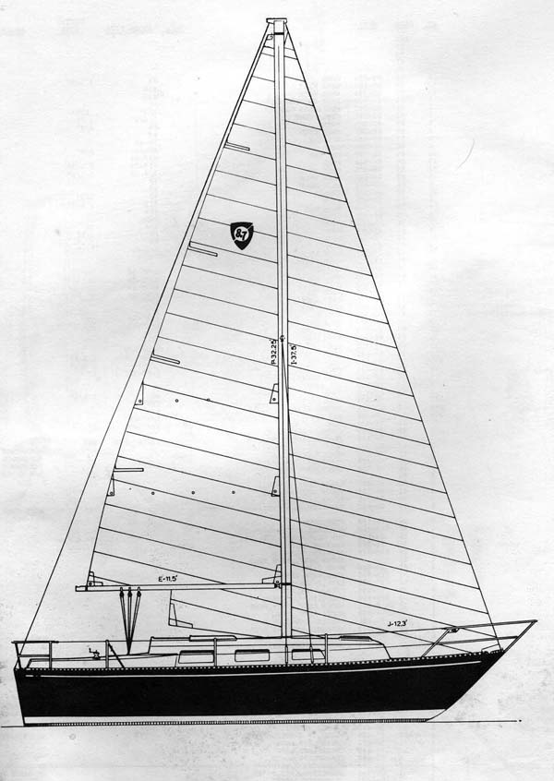
Full Sail has three sails….

Mainsail
The mainsail is full-battened with two reef points. The full roach of the sail extends slightly aft of the backstay. This is the primary sail on Full Sail and she will sail reasonably well, if not optimally fast, on all points of sail with only the main set.

Headsail
Full Sail has a Roller Furling headsail. The Genoa is 140% and provides excellent drive in light airs (less than 18 knots apparent). Once the apparent wind approaches twenty knots it is best to reef to the 115%. This reefed sail is very flat with only a slight overlap of the mast and can handle apparent winds up to thirty knots. The furler is a Bamar COT. It has Delran Bearings and requires only occasional fresh water rinses to maintain smooth movement.

Cruising Spinnaker
The cruising spinnaker on Full Sail is a North Sail Gennaker asymmetric. The spinnaker is set and doused using a Chutescoop sock. To set the spinnaker first secure the sail bag to the toe rail or a lifeline stanchion. The piston hank is used to clip the tack of the sail to the fore stay. The tack has a down haul which is run through the block on the stem to a cam cleat secured to the toe rail with a snap shackle. Run the sheets through snatch blocks on the toe rail to the cockpit. The snatch blocks are normally set up aft of the sheet winches. Now attach the jib halyard to the shackle on the head of the Chutescoop. Raise the Chutescoop the masthead. Be sure to remove any twists in the Chutescoop before you raise the sock. With the leeward sheet secured, pull down on the Chutescoop halyard to raise the sock and let the sail fill with wind. If there is a fresh wind (greater than 12 knots apparent), it is best to turn the boat nearly dead down wind and raise the spinnaker in the lee of the mainsail. Secure the Chutescoop halyard to the mast, trim the spinnaker and then adjust the trim as you bring the boat onto your intended course.
To douse the spinnaker, reverse the process. If in a fresh breeze turn the boat down wind and blanket the spinnaker behind the main sail. Pull the sock down over the sail to douse it, and then drop the halyard to bring the sail on deck. Finally stuff the sock and sail back in the sail bag and secure the halyard.

Anchoring
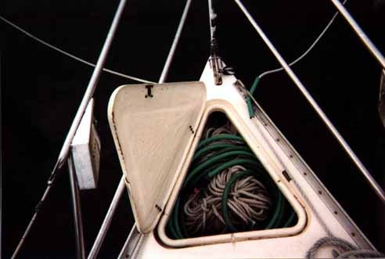
Full Sail has three anchors, a 25-lb CQR, a Fortress FX-11, and 12 LB Danforth with 200’ of nylon rode & 50’ of ¼ chain. Two anchors and the rode are stored in the anchor well on the foredeck (Danforth is stored in the cockpit locker). I normally flake the rode into figure eight’s and then secure them with small stuff. This allows the anchor rode to run easily from deck when the anchor is dropped. On the Chesapeake Bay I rarely anchor in more than 15’ of water.

Canvas
Full Sail has a full set of deck canvas to protect the cockpit and the sails.

Dodger
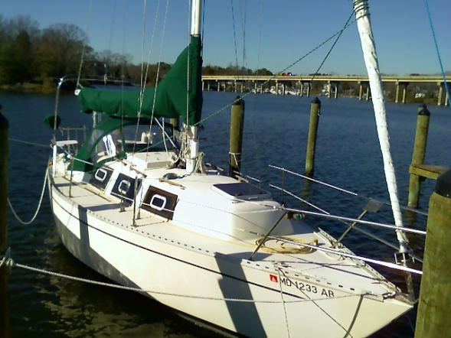
The dodger provides wind and spray protection for the crew in the cockpit. It also provides a handhold when standing in the cockpit. The center clear vinyl window can be unzipped and rolled up to allow a breeze in the cockpit when motoring. In a hot anchorage with little wind I normally drop the dodger to allow for maximum air movement through the cockpit. When motoring in hot sun I normally set the cockpit awning off the dodger. This awning normally can’t be set under sail because the mainsheet must run through the opening in the awning.

Mainsail Cover (retired but retained)
The mainsail cover is a “Horse Blanket” style cover and is secured around the mast, sail and boom with Twist locks.

Mainsail Pack.
The mainsail pack works in concert with the lazy jack system to allow quick and easy storage of the main sail. To open the pack just unzip the top zipper which will allow the sail to be raised or lowered easily. Attach the halyard to the sail and raise in normal manner. When dropping the sail, one only needs to lower the halyard and the sail will be guided via the lazy jack lines into the pack which can then be zipped closed.

Hatch Board Bag
The hatch drop boards can be stored in the bag, which hangs on the underside of the cockpit locker.

Front Hatch Cover
The front hatch cover is held down by snaps and was designed to hold a throwable deck cushion underneath it making it comfortable place to sit while at the same time.
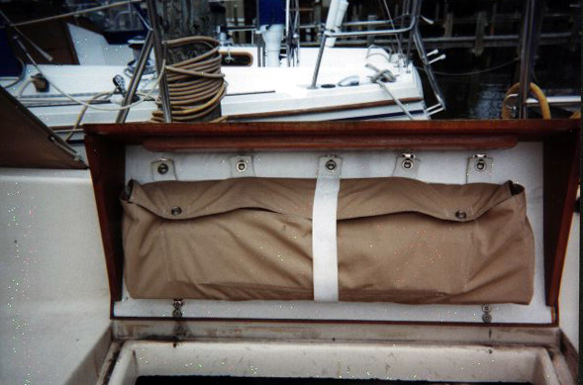

Diesel Engine

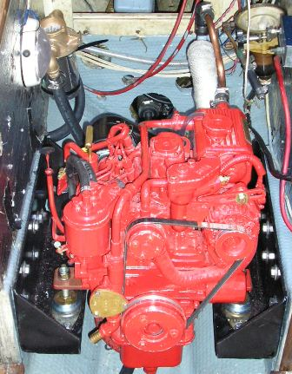
Overview
Full Sail’s engine was repowered in 2005 with a Beta Marine BZ602 16HP two cylinder diesel. The key to prolonged engine life is high quality lubrication oil and frequent changes. The key to reliable operation is clean fuel and frequent operation. Nothing kills an engine quicker non-use, except for maybe running it out of oil.
The companionway ladder is the cover for the engine compartment. There are two slide bolts that secure the cover. The engine compartment provides reasonable access to all maintenance components, but the engine was well shoehorned into the boat. There is very little excess space. Gaining access to the oil filter and the water pump impeller has been simplified with the new engine. The components are on the front of the engine.

Fuel System
Diesel fuel is stored in a twenty-gallon aluminum tank located under the cockpit sole. The deck fill is located just outboard of the forward cockpit coaming on the starboard side. The tank vent is on port side of the transom. Two fuel lines run between the tank and the engine. One line delivers fuel to the engine the other returns unused fuel to the tank. There is a shut off valve on the top of the fuel tank, which is connected to the delivery line. The delivery line enters the aft end of the engine compartment on the port side and connects to the Racor 500FG-filter/water separator. The return line runs from the injector pump on the starboard side of the engine back to the tank. Fuel flows continuously through the fuel lines and is delivered to the cylinders whenever the injectors open. Therefore, fuel flow through the lines is much greater than the rate of consumption. This means most of the fuel delivered to the cylinders has run through the filters more than once.
Fuel flows from the Racor filter to the priming pump on the aft end of the engine block. The priming pump has a small lever-operated pump that can be used prime the fuel system and remove air from the lines (see bleeding the fuel lines below). The priming pump has a small filter screen under the top cover. The cover should be removed, and this screen cleaned periodically, but as long as the Racor is doing its job this screen should never become clogged.
The next filter on fuel system is the spin-on filter on the aft end of the engine. As with the filter screen on the priming pump, this filter should never become clogged. It is usually changed every other year.
Finally, the fuel flows to the injector pump, passes on through the injectors and then back to the tank via the return line which runs along the starboard side of the engine compartment.

Cooling System
The BZ602 engine is fresh water-cooled. A heat exchanger system is seawater is drawn in through the ¾” seacock under the galley sink by water pump on the front portion of the engine. Before the water reaches the pump, it passes through the Groco water strainer. This is an acrylic bowl with a Monel screen basket inside. The basket will capture most solids in the water that could damage the pump impeller (see direction below for clearing the water filter).
From the pump the water enters the engine manifold The water mixes with the exhaust gases and then settles into the water trap/muffler, which is located aft of the engine compartment under the fuel tank. The pressure of the exhaust gases will push the water through the exhaust hose and then out the thru-hull fitting at the bottom of the transom. (Note: The pump impeller should be replaced every year, it is cheap and easy to do, a spare can be found in the Orange box located behind the head).

Operation
There are few controls on the engine therefore by definition the operation of the engine is straightforward and simple. The single lever throttle and gear shift is located on the forward starboard side of the cockpit well. The engine instruments are in a recessed panel at the base of the bridge deck.
Before starting the engine, insure that the seacock for the cooling water is open. Operating the engine without cooling water for a few minutes will not damage the engine but could destroy the water pump impeller. Operating the engine without cooling water until an overheat condition occurs can cause severe engine damage.
From the cockpit insure the gear lever is in neutral, and then turn the key on the engine instrument panel. Hold the key until engine starts or a maximum of 20 seconds. If the engine doesn’t start in that time, release the button and let the batteries recover for at least 30 seconds before attempting to start the engine again. In cold temperatures, the key can be turned and held in the “heat position” for about 10 - 15 seconds. This will allow for a smoother start.
Once the engine has started, check that water is flowing out of the exhaust thru-hull. If water does not start to flow within a minute shut down the engine and determine the reason before attempting to restart the engine.
Assuming the engine started successfully, the forward or reverse gear can now be engaged to get under way. However, it is advisable to let the engine warm for a short period before engaging the transmission. Pushing the shift lever forward engages forward gear. Pulling the shift lever aft engages reverse. When the shift lever is vertical the transmission is in neutral. To warm the engine, press the button at the lower point of the control in, which will lock out the transmission shift control and advance the throttle to bring the RPM’s up without engaging the prop.

Once the boat is clear of the dock and other obstacles bring the engine slowly up to the cruising speed of 2900 RPM. The engine can be operated indefinitely at this speed. It can be operated briefly at higher RPMs up to 3600 for maneuvering or getting off of aground. The alternator is controlled by an Adverc Battery Management System. It will start to produce current at a level required by the batteries. This can be verified at the Link 10 Monitor above the auxiliary electrical panel.
When stopping the engine, allow it first to idle in neutral for several minutes. Then depress the shut-off button on the engine control panel until the engine comes to a stop.

Maintenance
The Beta Marine engine is a simple diesel engine and the owner can perform all normal maintenance functions.

Oil Changes
Oil changes are performed quite simply by evacuating the oil with the oil change pump on the starboard side of the engine. First run the engine for a few minutes to warm the oil. Don’t run the engine more than five minutes to keep the oil from becoming too hot. Stop the engine, remove the plug on the manual pump and attach a hose to the bottom. Turn the stopcock under the pump and pump as much oil from the pan as possible. Next remove and replace the oil filter, which is located on the port side of the engine below the air filter and behind the starter motor. The filter is right on the front of the engine for easy access. The filter should never be tightened more than hand tight, so you should be able to unscrew the filter by hand. Be careful not to spill too much of the oil in the filter when you remove it. If the filter has become stuck and can’t be loosened by hand, try one of the many varieties of filter wrenches to break if free. When all else fails, push an ice pick through the filter cover and use the pick as a lever to break the filter loose. Install a new filter, first wiping a little oil on the filter gasket. Remember to not over-tighten the filter when you screw it on. Remove the oil fill cap on top of the engine. Pour in fresh oil in approximately the same volume as you removed. Wait a few seconds for the oil to reach the pan and check the dipstick for the oil level. If the oil has not reached a point between the two marks on dipstick, add more until the proper level has been achieved. Replace the oil fill cap. Now start the engine, run it for five to ten minutes, and shut it down. Re-check the oil level. The new oil filter will now contain oil and you may need to add more oil to compensate.
With that the oil change is complete.

Fuel Filter Replacement
There are two times to replace the fuel filter. One is every spring as a precaution and the other is when the engine stops for no apparent reason. There are only a few reasons that a diesel engine will stop once it has been successfully started. One is the loss of compression; another is loss of oil, a lack of air, and finally a lack of fuel. The first two are either the result of a catastrophic failure in the engine or will surely result in one. The BZ602 is naturally aspirated, so air delivery is rarely a problem. Thus the only problem that can stop the engine that can be easily owner corrected is the lack of fuel. Normally this is the result a clogged filter. The Racor filter is very fine, and introduction of solids (algae, dirt, or fungus) into the fuel supply can quickly clog the filter and cut off the fuel flow. Over time even reasonable clean fuel can clog the filter, however the annual filter replacement procedure should prevent that from ever shutting down the engine. Therefore if a fresh filter becomes clogged you can be sure that you have contaminated fuel. You may have to replace several filters to get back to your berth and replace the fuel.
To replace the filter, first stop the engine and shut off the fuel supply at the valve on top of the fuel tank. Next remove the t-handle on the top of the Racor filter. Next remove the filter-housing lid. There are two thin O rings underneath the lid. Retain these or replace them with new ones that normally come with the replacement filter cartridge. Next pull out the filter cartridge and examine it. If clogged, the filter should be badly discolored. Even if it doesn’t look bad, we’ve come this far so you might as well replace it.
Before you install a new cartridge check the fuel in the filter bowl. Look for a color discontinuity to indicate that water has collected in the bottom of the bowl. If it looks like there is water in the fuel now is the time to remove it from the bowl. Even if the bowl looks OK, it’s not a bad idea to drain a little just to be sure. To drawn fuel from the bowl hold a receptacle (Ziploc bags work well) under the bowl and loosen the drain plug at the bottom of the bowl. The fuel should start to drain into the receptacle. Once the discolored fuel or water has drained from the bowl, shut off the drain.
Now put a fresh cartridge in the filter. Secure the O rings in their slots on the filter housing and replace the lid. This can be tricky, especially if you are using new O rings. For some reason Racor twists the O rings into a figure 8 when they package them. This makes the package smaller, but it also means the O rings refuse to lie flat in their slots. It will probably take a few tries to get the lid secured with the O rings in place. Sometimes you can’t tell until you re-fill the bowl with fuel and see it start to flow out of the top. This brings us to re-filling the bowl and bleeding the fuel lines.

Bleeding the Fuel Lines
Any time you replace the filter cartridge or run out of fuel you have likely introduced air into the fuel lines. Air will block fuel flow and make it impossible to start the engine. After a filter cartridge replacement there are two ways to re-fill the bowl, quick and dirty or slow and less dirty.
First quick and dirty.
With the filter lid still loose, open the fuel valve on top of the fuel tank. Fuel should start to flow by gravity into the bowl. When fuel starts to flow out from under the lid, tighten the t-handle until the flow stops. Here’s where not properly securing the O rings will bite you. If the O rings are not in their slots you will not be able to stop the fuel from leaking out of the filter. You’ll have to shut of the fuel, remove the lid, try to re-secure the O rings and start over.

The less messy way to re-fill the bowl is to use the priming pump down stream from the filter. First securely clamp the filter lid and open the valve on top of the fuel tank. Now work the pump lever up and down to pull fuel into the bowl. Once the bowl fills up check to insure the O rings are in place and no fuel is leaking.
At this point you have filled the bowl either the quick and messy way or the other way. Now you need to continue to pump fuel using the priming pump with the bleed valve open. You should see fuel flow out of the valve. Initially it will have lots of air bubbles. Keep pumping until the air bubbles disappear and you are pumping solid fuel. Close the bleed valve securely. Try to start the engine. It should start now. If it does not, you probably did not completely bleed the fuel lines or you have a leak somewhere (probably one of points where you attempted to bleed the lines – filter, bleed valve, or injectors). Check for leaks, seal them and try the process again. Good Luck!

Raw Water Filter/Impeller
If the engine operating temperature is within the normal range, and water is being ejected with the exhaust you have no reason to service the raw water filter or the water pump impeller. When one of those things are not normal then it’s time for service.
Before attacking the impeller check the filter. If there is blockage you may not be able to detect it by inspecting the bowl from outside. Shut off the water intake seacock under the galley sink. Next unscrew the lid on the water strainer and pull out the Monel screen basket. Clean the basket and replace it in the bowl. Screw the lid back on securely. If you found a lot of debris in the basket, that is likely the cause of the problem. However, if the water flow was blocked for a period you may have also damaged the impeller. You might as well just start the engine (open the seacock first) and check for water flow. If you’ve already damaged the impeller another few revolutions won’t do any more harm. If you don’t see any water in the exhaust after a minute of operation shut down the engine and move on to the impeller.
The impeller housing is also on the front of the engine for easy maintenance. There are three small bolts (10mm wrench) that secure the lid on the housing. Carefully remove these bolts and pull off the cover. If possible, save the paper gasket and O-ring on the underside of the cover. If it cannot be saved, the replacement impeller should come with a replacement gasket and o-ring. A fair amount of water from the filter bowl and the hoses will empty into the containment pan under the engine bed. If you forgot to close the seacock, a lot more water will come in.

Before you remove the impeller inspect it and note how the impeller flaps are oriented in the housing. They will be bent back from the direction of rotation. It is helpful to bend the flaps on the replacement impeller in the same manner, so the impeller will turn easily in the housing when you first start the engine. The easiest way to remove the impeller is to pry it out with two screwdrivers. The impeller is attached to a keyed shaft that slides into the water pump. The shaft will come partially out with the impeller. There is a set screw in the impeller, which can be loosed with an Allen Wrench. Remove the old impeller and inspect it for damage. Also clean out the impeller housing with a soft rag. A piece of the impeller may have come loose and if it remains in the housing it could destroy the replacement impeller. Secure the replacement impeller on the shaft and carefully push it back into the housing. Replace the cover and gasket and secure with the small machine screws. Next open the seacock and start the engine. Within a minute you should see water coming out of the exhaust.

If the impeller has broken off any parts you may need to backwash the line to extract parts from the cooler. This is easy to do with a hose and removing the upper joiner at entrance to cooler.

Cleaning the Heat Exchanger Tube and Replacing Zinc Anode

The wasting zinc anode should be checked every six months and replaced every year or as necessary. The anode is attached to the bolt inserted in the aft end cap of the heat exchanger. Unscrew the bolt and replace the complete unit with a new one. Check for leaks.
It is possible for fine sea weed and other debris to get past the inlet filter and into the tube stack. This should be removed and cleaned. Drain off coolant into a bucket. Unscrew the 2 end cap retaining bolts (one each end of the tube stack). Remove the ‘O’ rings and pull out tube stack. Clean tube stack and end caps. Re-assemble using new ‘O’ rings. Do not over tighten end cap bolts and make sure the tube stack is the right way round. Re-fill engine with water/antifreeze solution and run engine up to temperature to check for leaks.

Winterizing or Storing the Engine

Any time the engine will not be used for an extended period of at least two months there are a few basic procedures that should be followed to insure the engine is not damaged by the lack of activity. This is especially true if the lay-up period is for the winter months in an area where hard freezes can be expected. These procedures apply to extended but limited period of storage. If the engine is going to be stored indefinitely, additional steps should be taken to inhibit corrosion in the fuel, cooling, and lubrications systems. The procedures described here are for storage up to four or five months.
The first procedure is to change the lubrication oil in the engine and the oil filter. Follow the procedures described in the oil change section, above.
After the oil has been changed the raw water in the cooling system should be replaced by an anti-freeze solution. I normally use the RV-type anti-freeze that is alcohol-based. This provides adequate protection for the moderate winters of the mid-Atlantic region. Areas that experience severe winters may require greater protection than that offered by the RV-type. It takes about a gallon of anti-freeze to completely flush the cooling system.
The first step in flushing the cooling system is to close off the intake seacock under the galley sink. Now remove the intake water hose from the seacock and connect 3’ extension hose using a male-male hose barb. Stick the end of the hose extension into the anti-freeze container and start the engine. Watch the container to insure the water pump is pulling anti-freeze from the container. Then go to the transom and monitor the exhaust until you see anti-freeze being ejected. Quickly shut down the engine and replace the intake hose on the closed seacock.
If you used a petroleum-based anti-freeze you should also drain the raw water strainer. Petroleum-based anti-freeze is a solvent and will destroy the acrylic bowl of the water strainer. Using a wrench or a deck plate tool loosen the cover on the water strainer. Then unscrew the plug at the bottom of the bowl and let the anti-freeze drain into a receptacle.

Electrical

The electrical system on Full Sail is a combination of the original wiring and additions since original purchase. I must admit much of it falls into the spaghetti class of wiring. I have documented all this wiring in the large format diagrams included with this document and reproduced in this section. I have organized the wiring documentation into four diagrams.

- Circuit Control and Engine Harness

- Cabin Service Circuits

- Mast and Deck Circuits

Circuit Control and Engine Harness
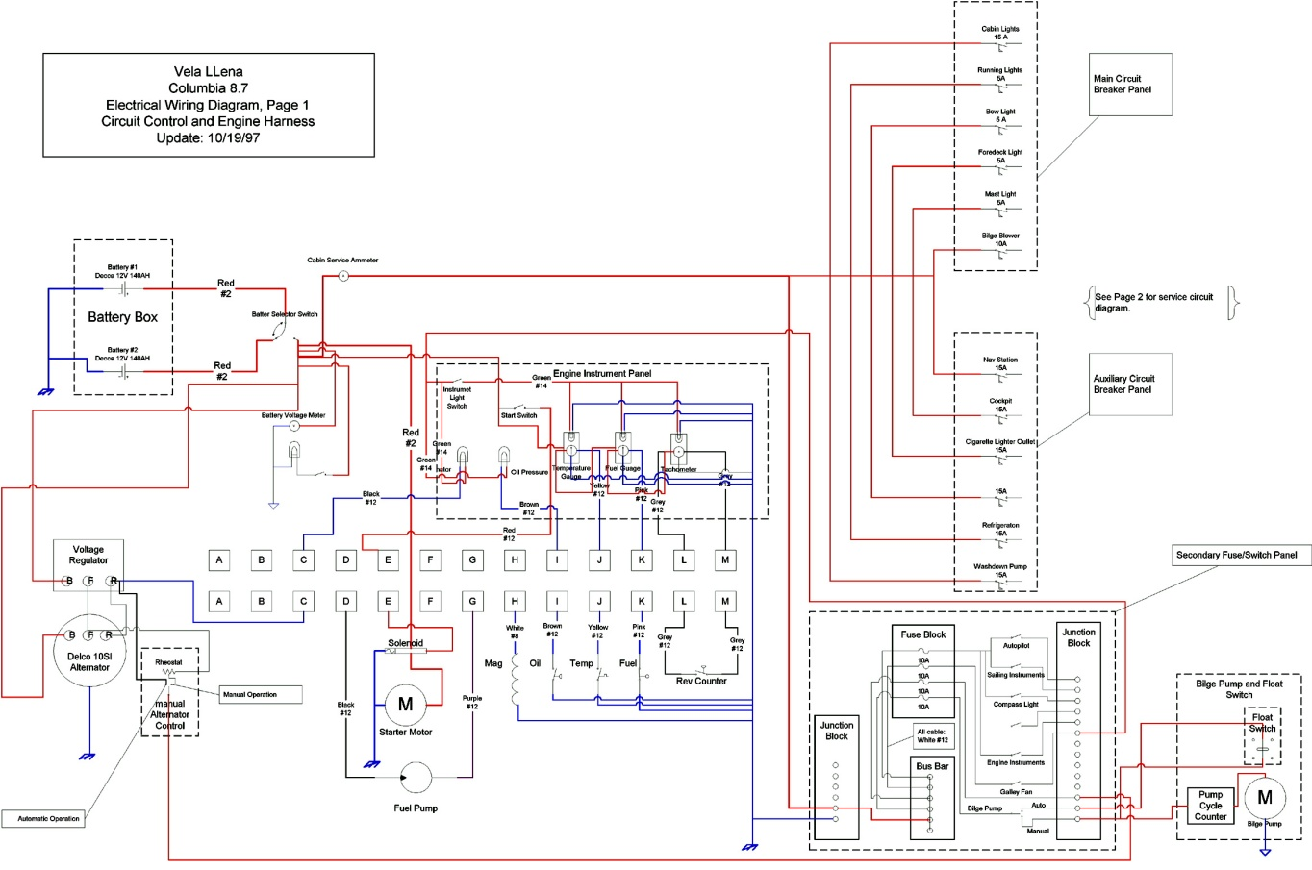
All of the circuits are controlled and distributed from one of three circuit breaker/switch panels. Full Sail was delivered with a single breaker panel with a battery selector switch, which is located above the galley sink, and depicted at right. On the right side of the panel are the battery selector switch and the battery voltmeter. This switch controls only the output of the batteries, not the charging circuits. The Newmar battery charger is wired directly to the batteries, and the alternator is wired to battery isolator and then directly to the batteries. Therefore, you don’t need to be concerned about someone accidentally switching the batteries off-line when the engine is running and destroying the diodes in the alternator.
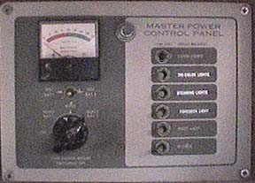
The circuit control and engine harness wiring diagram is reproduced above. The full-size diagram is included as an annex to this document.
The main electrical panel switches are depicted in the upper right of the diagram. There is a total of six circuit breakers on this panel, which control the following circuits.
- Cabin Lights: This 15-amp breaker activates the circuits to most of the cabin lights. Switches built into the individual fixtures control each of the lights.
- Running Lights: This 5-amp break turns on the Port and Stbd bow lights and the stern light.
- Steaming Light: This 5-amp breaker turns on the mast light on the front of the mast.
- Foredeck Light: This 5-amp breaker turns on the floodlight on the mast (in the same fixture as the bow light) that illuminates the foredeck.
- Mast Light: This 5-amp breaker turns on the anchor light on the masthead.
- Bilge Blower: This 10-amp breaker activates the circuit for the bilge blower to evacuate any explosive fumes that may work their way into the bilge. The blower is turned on and off by a pull switch on the engine instrument panel at the base of the bridge deck in the cockpit. Given that Full Sail’s engine does not burn gasoline and the stove uses lighter than air fuel (CNG), I rarely run this blower.

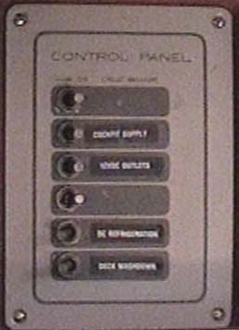
To the left of the main electrical panel is the auxiliary circuit breaker panel. This panel controls some of the additional circuits that I have added over the years and contains six circuit breakers. These breakers control the following circuits.
- Navigation Station: This 15-amp breaker controls the circuit for the navigation station at the head of the quarter berth on the port side of the cabin. This circuit feeds a bus bar on the aft side of the aft bulkhead in the navigation station. The VHF radio, the stereo system (including the power amplifier and CD changer) and the lights over the navigation table all receive power from this bus bar.
- Cockpit: This 15-amp breaker activates the dry-plug receptacles in the cockpit and at the base of the mast on top of the cabin trunk. These receptacles are used primarily for the spotlight.
- Cigarette Lighter Outlet: This 15-amp breaker activates the cigarette lighter receptacle on the forward side of the bulkhead after of the galley stove. This receptacle is used primarily as an outlet for portable devices that can be plugged into an automotive cigarette lighter (e.g., a cell phone charger). It could also be used to light cigarettes, but it never has.
- Miscellaneous: The fluorescent light above the electrical panel.
- Refrigeration: This 15-amp breaker activates the circuit for the Adler-Barbour refrigeration. The refrigerator is turned on and off by the thermostat switch located inside the icebox.
- Washdown Pump: This 15-amp breaker controls the circuit for the deck wash down pump, which is located under the port v-berth. The washdown pump is turned off and on by the pull switch located under the v-berth insert in the forward cabin. Never turn on the wash pump when the water feed seacock under the sink is closed.

Secondary Panel

Located under the cabin stairs you find the secondary or auxiliary panel. This panel as shown below contains an assortment of controls for the assorted electrical devices as well as the shore powered breakers.

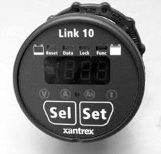 Just outboard of the auxiliary panel is a Link 10, which measures the current delivered by the batteries to the active circuits on the boat. I use this ammeter to monitor the current usage while at anchor or under sail. It is also a useful tool in diagnosing refrigeration problems.
The third electrical panel is the secondary fuse/switch panel on the bulkhead behind the companionway steps. This panel controls the last set of circuits added to Full Sail.
Breakers protect the circuits on this panel. The switches are just that, not breakers the breakers are activated by the push button next to the switch. 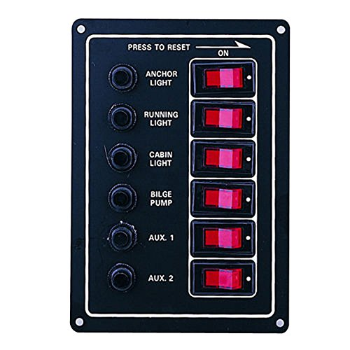
The switches and fuses control the following circuits.

- USB chargers – 2 sets located near top of panel they are able to provide 5 amps at 5V for charging devices.
- The panel light – This is a low draw LED bar which can be keep on as needed, (there is a switch which allows the lights to be White or Red for night.)
- Nav2 – The built-in navigation systems (2) which are documented in the electronics section.
- Music – powers the Sony radio for music
- Long Range WiFi – powers the Bullet WiFi which is wired into the boat’s internal wifi allowing greater than normal connections to access points.
The following have moved to the original breaker panel.

- Autopilot: This switch activates the autopilot control head in the cockpit. This also activates the flux gate compass, which located under the forward end of the port settee berth in the main cabin. The Garmin Chart plotter is also powered through this circuit.
- Sailing Instruments: This switch activates the Autohelm wind, depth and speed instruments in the cockpit. It also activates the Autohelm multi display above the navigation station.
- Compass Light: This switch turns on the light in the Ritchie compass in the cockpit.
- Engine Instruments: This switch activates the fuel gauge.
- Galley Fan: This switch turns on the oscillating fan over the stove in the galley. There is also a switch on the fan.

In addition to these circuits, the panel contains the switch and cycle counter for the electric bilge pumps. The primary pump is located under the furthest aft of the lift hatches in the cabin sole, the second small pump is located in the forward bilge with access through the forward lift up hatch in sole. Both pumps are joined through a check vale “Y” and vented through the stern. The pump can be operated manually by the panel switch or automatically by the built-in float switch, which is located under the center hatch in the cabin sole.

Above the bilge pump switch is a meter that measures the charging current produced by the alternator when the engine is running or the solar panels as well as the state of the batteries.

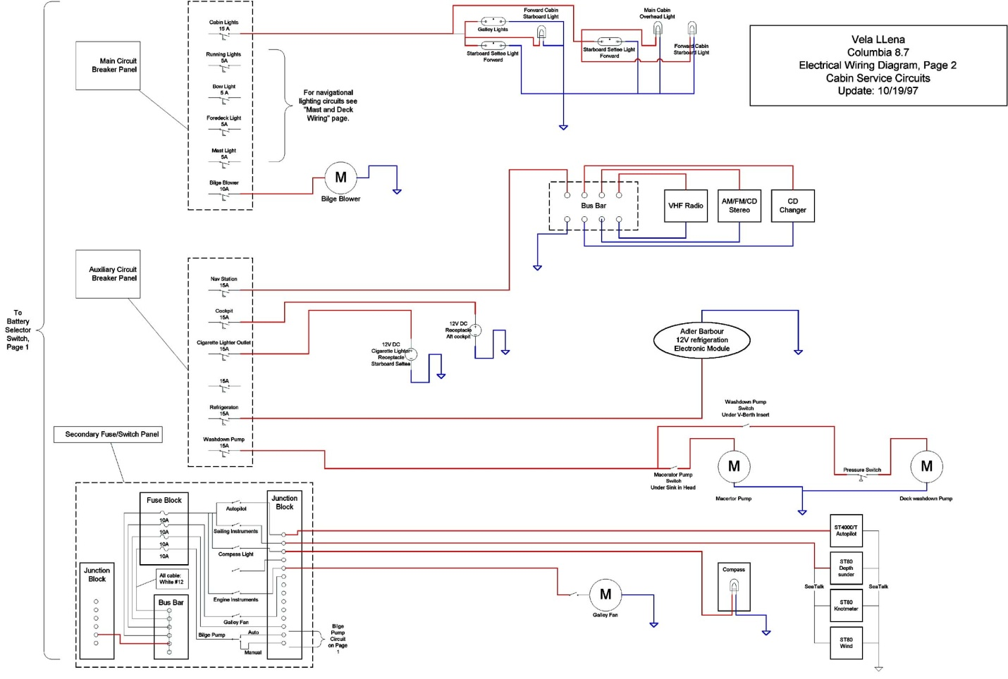
B. Cabin Service Circuits
The second diagram depicts the cabin circuits that are controller by all three panels.

Mast and Deck Circuits

The third diagram depicts the circuits in the mast and on deck. In particular it documents the wiring in the deck plug that connects the circuits in the mast to the deck.
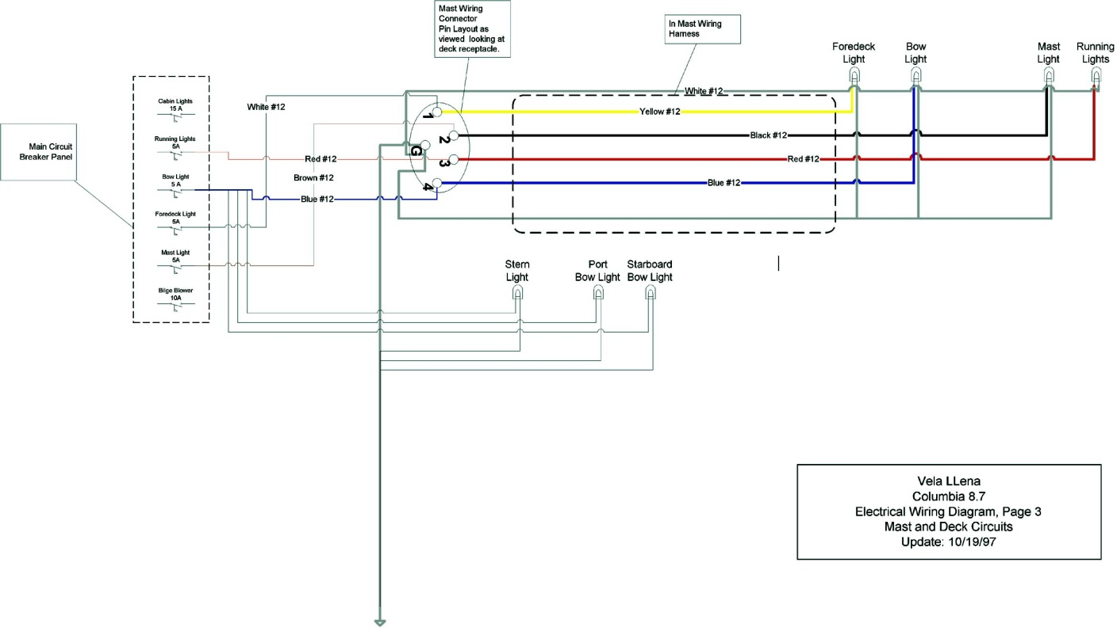

Battery Box Circuits – Charging/Shore/Alternator/Solar

The various battery connections are documented above. Full Sail has two (2) battery banks one for house power providing 470 Ah at 12V as well as a Motor Starter battery that can be isolated from the house bank to ensure the ability to start the motor regardless of the house bank. Key to shore independence is the Solar panels which are used to charge the battery, currently the panels are mounted on the coach deck and in this location their output is far less than they are capable of in the future an arch or the top of the Bimini will be provided to give them direct unshaded view of the Sun (they are able to produce up to 200 watts/hr when in direct sun view). While connected to shore power the charger will keep the batteries full, and under motor power they are constantly charged.

Navigation Station Panel

Core of the Plotter are 2 ARM based Raspberry Pi 3+ running Linux and the Openplotter software load.

Full Sail has a built in 7” touch screen display located at Nav station, but normal access is via iPad using RealVnc app or any other VNC remote desktop. The second plotter & screen are mounted on a swing down mount in the center of the cabin, from this position it can be seen from cockpit is any weather. This unit also has 500GB of movies and music which can be played at will.

The onboard router (sid: fullsail pwd: sailorboy) provides on-board Wi-Fi and allows mobile devices to act as remote desktop access point to the system.
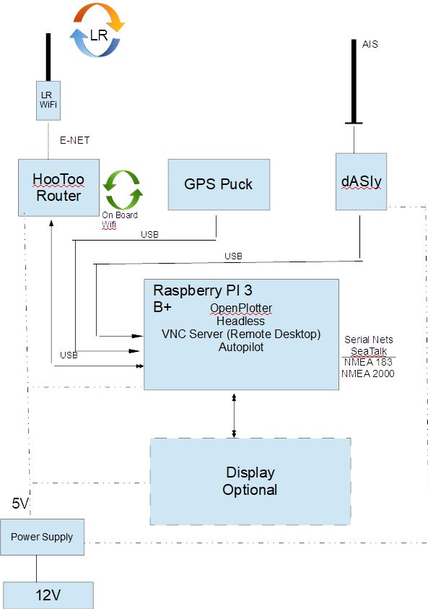

The dAISy 2+ device provides AIS info as well as NMEA 183 I/O, currently the AIS antenna is mounted on the aft rail. The AIS data is displayed on the Chart plotter and is enabled to define collision warnings as needed.

A global star BU-353-S4, a USB connected GPS receiver is located behind the panel just under the deck and directly connected to the RaspberryyPi. The GPS puck provides Lat/Long and altitude (although the boat tends to stay at sea level).

The Pi provides serial IO to the various seatalk devices and NMEA networks. A Long Range Wi-Fi receiver connects to the on-board router to supply INET from up to 50 km away.

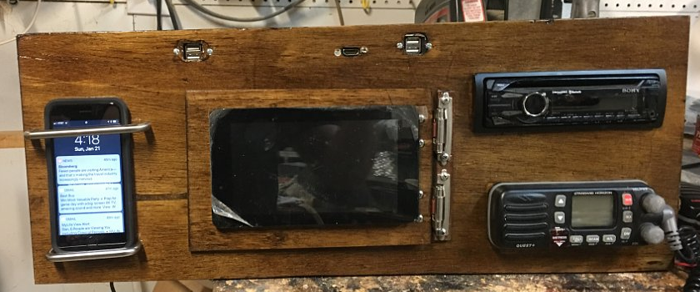

Below the Waterline
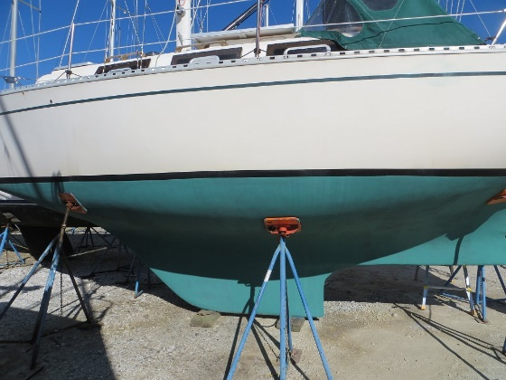
Below the waterline Full Sail does not resemble many of its contemporary designs. The keel is shallow and low aspect with a long skeg that runs aft to provide protection for the propeller. Above this skeg is another short skeg to which the rudder is attached. Alan Payne, the designer, calls this configuration a “skeg-on-a-skeg”. The forward sections are U-shaped to minimize pounding. The aft sections are flat to minimize wetted surface and to provide additional resistance to healing.
It is best to have the boat hauled annually to re-apply bottom paint and to visually inspect all of the underwater fittings. This is also an opportunity to inspect and lubricate all of the seacocks in the cabin.
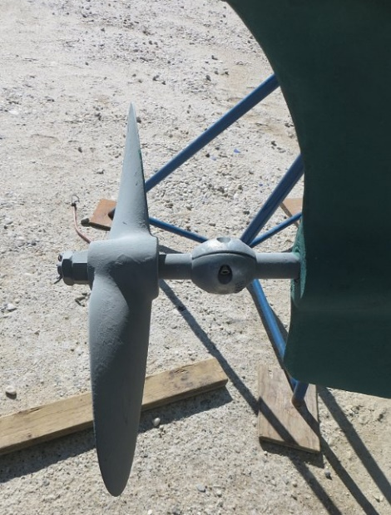
To apply a fresh coat of bottom paint you must first prep the surface. The boat yard should have power-washed the bottom and scrapped any barnacles or other growths from the hull. Using a disk sander (preferably a random-orbital one) smooth all painted surfaces below the water line. Before starting to apply paint use masking tape to cover the waterline. One gallon of paint is adequate to provide one coat to the hull and rudder. I have used different colors each year to determine if the paint is wearing thin.
The propeller and propeller shaft should also be cleaned and painted. A wire wheel or brush in a power drill makes fairly quick work of this task. If you are going to paint the prop, make sure you clean it extremely well. The bronze metal should be free of any contaminant and be brushed to a golden yellow. I have used an Interlux system successfully for an entire season. I prep the surface with the Tri-Lux wash, and then apply 2-3 coats of primer and then 2-3 coats of hard bottom paint. Be sure to replace the prop shaft zinc before launching.

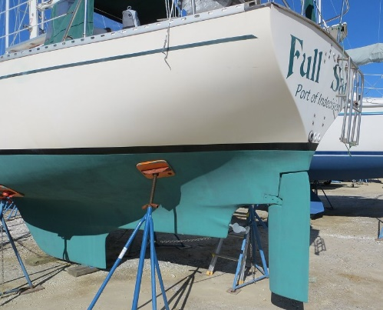
The keel profile, which shows its low aspect nature and shallow draft. The picture on the right shows the full bilges and flat underbody of the center sections of the hull. This keel and hull configuration allow Full Sail to cruise in shallow water while still providing a stiff hull that can stand up to a relatively large sail plan.

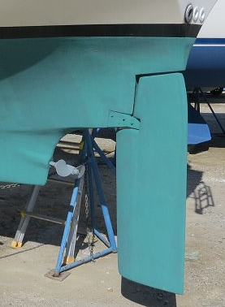
This picture shows the skeg and rudder configuration as well as a close up of the gudgeon that holds the rudder to the skeg. This configuration provides a partially balance helm and relatively effortless steering, eliminating any need for wheel steering on. The gudgeon is made up of two bronze pieces that wrap around the rudder shaft where it is exposed in the notch in the rudder. The gudgeon is through-bolted to the rudder skeg. As delivered from Columbia this skeg was hollow and the through-bolts where the source of slow, but persistent leak on Full Sail. Eventually I filled this skeg with epoxy and the leaks have ceased.

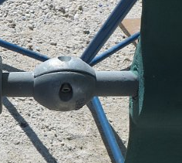
The picture below is a closeup of the propeller, shaft and the skeg. There is a cutlass bearing within the skeg, which provides a low friction surface within which the shaft can rotate. The cutlass bearing, and the shaft were replaced in 2005. The original 15x9 was prop was Left Hand Rotation and removed in 2005 when the engine was replaced. Currently, Full Sail has a Teignbridge 15 RH 8 prop installed.

Which brings us to Prop Walk.
Pivoting a Boat
A common situation where prop walk can work for or against you is when maneuvering a single-screw vessel in tight quarters. Using prop walk, you can pivot a boat in place, or nearly so.
Always turn a boat with a right-hand propeller to starboard, rotating her clockwise. Put your wheel hard over to starboard (or push your tiller hard to port), then give the throttle a sharp 1- or 2-second burst of power in forward. The prop wash hits the cocked rudder and begins turning the boat. Since the idea is to turn in place, don’t stay in forward gear for long. Throttle down to idle, shift to neutral for a moment, then shift to reverse and give her another strong burst of power. This stops the boat’s forward motion and kicks the stern to port, increasing the lateral rotation. Idle down, shift back to neutral, and then into forward again.
Keep repeating this sequence, alternating throttle bursts in forward and reverse, until the boat has spun to the desired heading. Throughout this maneuver, keep the helm turned to starboard—the rudder should have no effect in reverse, since the boat’s not making sternway—and always spend a moment in neutral between each shift to spare the transmission any sudden jolts.
This technique will spin most boats in their own length, plus a little—a bit less for fin-keel boats, more for longer keels. It only works pivoting to starboard with a right-handed prop or to port with a left-handed prop. If you try to pivot the wrong way, prop walk will work against you each time you power up in reverse, slowing or even thwarting the turn. If you must turn a right-hand prop boat 90 degrees to port in tight quarters, you’ll probably be better off spinning her 270 degrees to starboard. Practice pivoting your boat in open water until you get the feel of it.
For Docking Prop walk can help as it will apply force to the stern of the boat to either port or starboard depending on the gear you are in. In Full Sail’s case with a Right-Handed prop backing into a slip can be eased by prop wash pushing the stern to the port side.
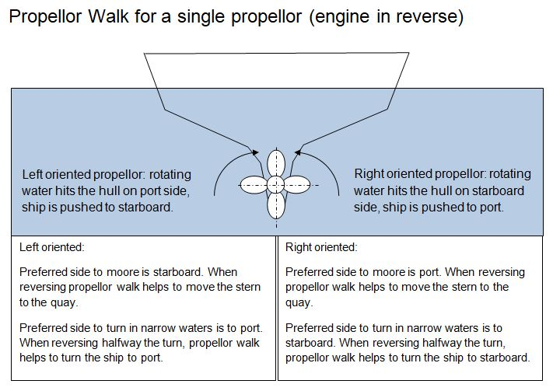

Cabin Systems Overview
This section describes the operation and maintenance of the various cabin systems installed on Full Sail. These systems include the following.

Ventilation
The hatches, portlights and vents that allow air to flow through the cabin.

Plumbing:
The tanks, hoses and pumps that move fluids into, out of, and within the cabin.

Galley:

The stove, refrigerator, and sink used for meal preparation

Head:
The toilet and other sanitation devices.

Navigation Station
The chart table and navigation instruments.

Ventilation System
The ventilation system consists of the hatches, ports and vents that allow air to flow through the interior of the cabin. This airflow is necessary not just for human comfort but also to preserve the woodwork, electrical wiring, and other systems within the cabin that are attacked by mold and corrosion.

Companionway Hatch
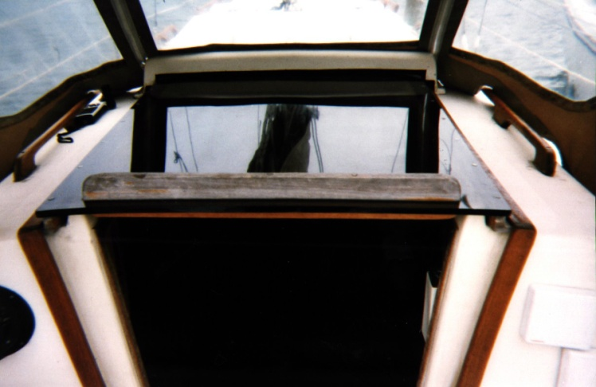
The companionway hatch consists of a sliding hatch cover and removable drop slides (see figure 1). This hatch provides the main access to the cabin from the cockpit. The hatch is protected by the canvas dodger and thus can be left open most of the time while underway, at anchor, or tied to the dock. This is the largest opening into the cabin and provides the primary ventilation.

When it is raining and the boat is underway, tied to a dock or swinging at anchor such that the wind is abeam or abaft it may be necessary to insert all but the top drop slide in place to prevent rain from entering the cabin. Except when the wind is blowing directly from astern, the top slide and the overhead hatch can be left open and no significant amount rain will enter the cabin.
This is the fourth hatch cover built for Full Sail. The initial cover was made of teak veneer plywood. The veneer on this hatch delaminated within a few years and Zahniser’s Boatyard constructed a new one of plywood with solid teak strips rather than veneer. This hatch lasted for over 15 years, but finally the plywood also began to delaminate. The fourth hatch was built in 2017 of 3/8”Plexiglas. I don’t expect this one to delaminate.

The current drop slides were built in 1988 when the original plywood drop slides also delaminated and then refinished in 2017. A Plexiglass single unit was built in 2016 to be used when the boat is stored or just to prevent wear and tear on the drop boards which were refinished in 2017. The drop slides are stored in a canvas pouch that is secured to the underside of the cockpit locker.

A curtain with drop in rod was created in 2021 to allow overnighting sailors to sleep in as needed.

Maintenance: Beyond keeping the hatch clean the only maintenance required is to regularly apply Semco, or similar products, to the teak on the sliding hatch and to varnish the drop slides at least annually.

Forward Hatch
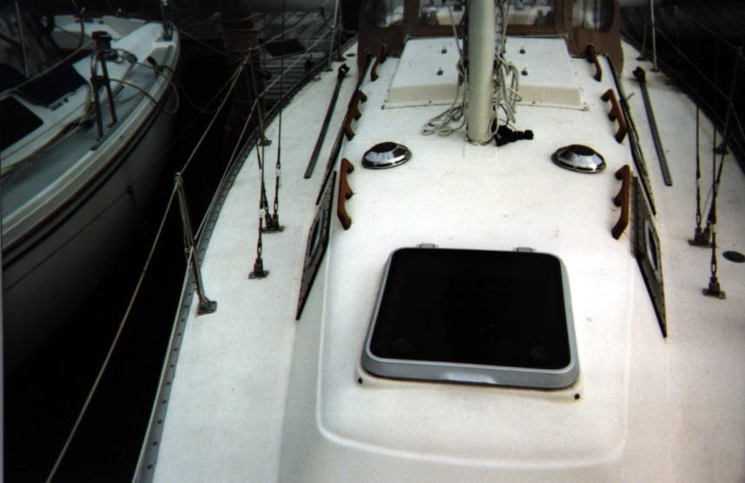
The forward hatch is a 22-1/2" Lewmar Roll Stop Hatch that I installed to replace the original Bomar Hatch in 1990. The Bomar hatch could not be secured to prevent leaks. I had a canvas cover built for that hatch which stopped most leaks. When that cover began to deteriorate I decided it was time for a new hatch.
The two handles on the forward edge of the hatch cover secure the Lewmar hatch. The handles can be operated both from within the cabin and from on deck.
To open the hatch, rotate the handles outward until they are parallel to side edges of the hatch. This releases the cams that secure the hatch cover. Pushing or pulling the cover upward to one of the roll-stop positions opens the hatch.
The Hatch may be secured in two positions: fully sealed and ventilation. To fully seal the cover pull or push it fully down so that the gasket in the cover is pressed against the frame then turn the handles inward until they are parallel to the forward edge of the hatch. The cams should slide under the frame and seal the gasket against the frame. In this position the hatch provides a complete watertight seal.
To secure the hatch in the ventilation position pull or push the hatch down until the cams on the handles line up with the slot in the frame. Turn the handles inward so that the cams slide into the slot until the handles are parallel to the forward edge of the hatch. In this position the cover is secure, but will allow air to flow under the forward edge of the cover. The lip on the cover provides a spray shield in this position, but water can enter and drip onto the forward berth in a driving rain or when beating into a chop.
The hatch can be locked in either secured position by pushing the levers inside the handles toward the end of the handle. The lock is released by pushing the levers in the opposite direction. The hatch can be locked only from inside the cabin. When locked, if someone should attempt to force the hatch open from outside by turning the outside handles these handles will shear off.
Maintenance: Beyond keeping the hatch clean the only maintenance required is to regularly apply Armor-All, or similar products, to the gasket on the cover.

Portlights
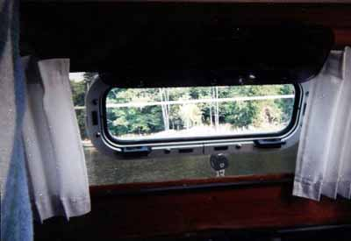
There are five Lewmar opening portlights in the main cabin plus one more in the head compartment for a total of six ports, three on each side of the trunk cabin. The aft portlights on each side are 4"x14" and the remaining four portlights are 4"x10". Two cam dogs on the lower edge of the lexan window secure each portlights. The handles on the dogs are turned inward so that the cams slide into the slots on the portlight frame the window is pushed against the gasket on the frame providing a watertight seal.
Releasing the dogs and rotating the window inward on its hinges opens the portlights. The click-stop hinges will hold the window in one of the pre-set open positions.
Maintenance: Beyond keeping the portlights clean the only maintenance required is to regularly apply Armor-All, or similar products, to the gasket on the frame. Over the years it appears that the lexan portlights need to be resealed every five years with new silicon, this is easy to do one only needs to unscrew the light clean off the old silicon, reseal it with fresh and screw them back on while ensuring the screw hole are also sealed.

Vents
There are three all-weather vents on Full Sail. One is located on the top of the transom and the other two are located in the top of the trunk cabin just forward of the mast
The transom vent provides ventilation to the refrigeration unit located under the cockpit sole. The combination of the engine exhaust line that is looped under the port quarter and the refrigerator can cause a significant buildup of heat under the cockpit. The vent will remove a great deal of this heat.

The trunk cabin vents are Nicro Marine Solar Vents. One of the vents is located in the head compartment and is normally set up in exhaust mode. The other is just outside of the head compartment and is normally set up to pull air into the cabin. Both vents have built-in solar panels that provide the power necessary for the fans. These units also allow the use of a NiCad battery to provide power when sunlight is not available. I have removed the batteries, as I was not satisfied with the battery operation of these vents. The batteries are expensive and have a limited life expectancy. Normally the fans are not required when the sun is not shining. And, finally, the fans made too much noise at night when the batteries were working.
Replacing the fan blade can change the airflow direction of each of the vents. To remove the fan blade, grab it securely and carefully but forcefully pull it down until it releases. Insert the replacement blade by pushing it up onto the motor spindle. Check the blade rotation to insure it does not strike or brush against the side of the vent housing. The blades are coded by the colored dot on the blade cylinder. Exhaust blades have a red dot and the intake blade has a blue dot.

Both trunk cabin solar vents are of the push-in, pullout type. The entire vent can be removed by grabbing the outer edge of the top of the vent pulling it out of through-deck frame. A plastic cover can then seal the frame. This should be done when sailing in rough conditions primarily to preclude catching a sheet under one of the vents and ripping it apart. The vents would also allow a considerable amount of water below should the boat take a knock down. Under normal conditions (rain showers, deck spray, etc.) no water will enter the cabin from these vents.
Maintenance: The only maintenance required is to keep the solar panels and the internal fans clean.

Plumbing
Full Sail is equipped with a relatively simple plumbing system that consists of four (4) through hull fittings, and a non-pressurized fresh water system.

Through Hull Fittings
Two of the four fittings are located under the galley sink and the other two are located under the sink in the head compartment. All are fitted with Groco Seacocks.
The through hulls under the galley sink are both fitted with 3/4" seacocks. The outboard seacock provides the drain for the galley sink. The inboard seacock provides seawater coolant for the engine and seawater to the salt-water pump on the galley sink. Removing the garbage pail from under the sink provides access to these seacocks.
The through hulls in the head compartment consist of one 1-1/4" seacock that provides the overboard discharge for the head and a 3/4" seacock that provides the drain for the sink and seawater input for the toilet and the deck wash-down pump.
All seacocks consist of cast bronze housing and a Stainless ball valve which is rotated by the handle. When the handle is vertical the seacock is open and when it is horizontal the seacock is closed.
Whenever the boat is to be left unattended for an extended period of time, all seacocks should be closed and sealed.
Maintenance: The seacocks require only annual maintenance, although they should be checked for a tight seal and good hose connections on a regular basis. Annual maintenance is best performed when the boat has been hauled. At this time the seacock can be inspected and greased.

Fresh Water System
The fresh water system on Full Sail consists of a single 20-gallon plastic tank located under the port settee, a foot pump and faucet at the galley sink, and a hand pump at the sink in the head compartment. All hoses are 1/2" I.D. clear vinyl.
The galley pump is located below the sink beneath the built-in garbage pail. The foot lever protrudes through the bottom of paneling under the sink. The pump is double action, delivering water on both the up and down stroke.
The head sink pump is located on inboard edge of the sink and is operated my moving the pump handle forward and backward. This pump is single action and delivers water only on the forward movement of the handle.
The freshwater tank is filled from the deck pipe on the port side directly opposite the head portlight. When filling the tank you should monitor the galley faucet. Once the tank is full water will flow freely from this faucet. The overflow vent for the tank is located in the head closet behind the toilet and will be spilling water into the bilge at this time.

Maintenance: The pumps require little or no maintenance. The tank should be cleaned at least annually. At a minimum this should involve the pouring of one cup of liquid bleach down the fill pipe and filling the tank with fresh water. Each pump should then be operated to allow the bleach solution to move into the hoses and the pump housings. Then the tank should be allowed to sit overnight, drained, then refilled and drained repeatedly until the taste and odor of the bleach is gone. This procedure should prevent the build up of algae and mold in the tank and the hoses.
Eventually the tank will require a thorough cleaning. There are two ports in the top of the tank for this purpose. These ports allow the tank to be cleaning with a mild soap solution by hand. This is most easily accomplished by removing the tank from the boat. To do this, remove the port settee bunk board. Disconnect the three hoses (deck fill, galley service and head service) from the tank and then pick up the tank. Be sure the tank is empty when you attempt this.

Galley
The galley is in the aft, starboard quarter of the main cabin and consists of the range/oven, refrigerator and sink. Shelves are provided outboard of the stove and above the refrigerator for the storage of cooking utensils and condiments.

CNG Stove
The Force 10 stove has two burners, an oven and a broiler. Currently the stove is set up for CNG fuel. It can be converted to propane by replacing the burner orifices with the propane orifices included in the spare parts inventory. I went with CNG to avoid having to build a sealed and vented enclosure for the tank. The CNG tank is stored under the forward end of the starboard berth/settee. This is not strictly according to code, because the code requires a sealed enclosure for CNG as well as propane. However, CNG is lighter than air and it will self vent as long as the cabin is ventilated. I believe the solar vents installed in the cabin overhead as well as the opening ports provide more than adequate ventilation. I have safely operated the stove in this manner for over three years. CNG is a more expensive fuel than propane and less convenient in that you must exchange the tank at an authorized dealer in order to get a re-fill. However, it is more than satisfactory for coastal cruising, as almost any harbor will have a dealer. Refer to the Force 10 manual for details on operating this stove.

Maintenance: The stove requires little maintenance beyond keeping it clean and respecting the fuel.

Refrigeration (To be Updated)

A 12V mini car fridge was procured and currently sits in the port quarter berth, it is powered by dock side AC when at dock and the house batteries at sea. Future plans have it being placed in the spot where the old unit was installed next to sink.
An Adler-Barbour 12-volt unit provides refrigeration. The compressor and condenser are located under the cockpit, just aft of the diesel fuel tank. The thermostat control knob is located inside the icebox on the inboard side. The refrigerator has a dedicated circuit breaker on the secondary electrical control panel behind the galley sink.
To turn on the refrigerator first turn the circuit breaker (second from bottom) on then turn the thermostat control knob clockwise to the "3" position. The compressor should now be running. This can be checked at the system ammeter behind the sink, which should show well above 5 amps of current (the compressor draws 6 amps). It can also be checked at the compressor by listening for the hum or observing the condenser fan in operation. Compressor operation can be checked at the evaporator in the icebox. You should head a tingling sound like a small waterfall at the evaporator. If the compressor does not come on, move to the trouble-shooting section below.
Once the compressor is in operation it will take from one to three hours, depending on the starting temperature of the box, for the icebox to get cold enough for fresh food. Leave the thermostat set between the "3" and the "4" positions. This is the normal operating temperature setting for the icebox. If it is set above "5" most of the contents of the box will eventually freeze and the batteries will be seriously depleted if the boat is disconnected from shore power. Settings below 2 will not keep food fresh during a hot summer day.

Continuous Operation: As long as the boat is connected to a reliable shore power source and the battery charger is active, I recommend leaving the refrigeration on continuously, even when the boat is not in use. Bringing a warm icebox down to the proper temperature level requires a lot of time and energy. It takes up to twenty-four (24) hours for the icebox to get cold enough to minimize the compressor operation. This means that if you leave the dock within twelve hours of turning on the refrigeration you will experience a great deal more battery drain while under sail than if the refrigerator had been operated continuously. The only danger from continuous operation is that should the shore power fail during the week when the boat is unattended; the battery will be fully discharged. The heavy-duty Trojan batteries seem to be able to take abuse, because it happened to me on more than one occasion. I don't leave anything that will spoil in the icebox when the boat is unattended.

Freezer: The evaporator case provides a somewhat inefficient freezer (unless the thermostat is on "7"), and I rarely use it for anything other than storing ice.

Trouble-Shooting: Refrigeration malfunctions normally involve either a compressor that will not start or an icebox that will not get cold enough. Trouble shooting the refrigeration system can be time consuming and complex. Detailed trouble shooting instructions are included in the Adler Barbour manual separate from this document. In this section I will cover only the most common problems.
The most common problem is a compressor that will not start. This can happen on initial start up of the refrigerator or after the unit has been running on a continuous basis for an extended period. This situation can be caused by a number of problems most of which are only temporary conditions.
The most common reason that will prevent the compressor from starting is low battery voltage. The compressor will run until the input voltage goes below 10 volts DC. At this time the compressor will shut down to protect itself and will not restart until the input voltage rises above 11-1/2 volts DC. Check the voltage meter on the active batter at the main electrical panel. If the voltage is below 11-1/2 volts switch to the other battery. If that battery is fully charged the refrigeration compressor should come on within 60 seconds. Recharge the original battery and try to determine the reason for the discharge.
The second most common reason the compressor will not start is a blockage in the high-pressure hose coming from the condenser. This happens most often on very hot days when the compressor is cycling on and off quite often. This situation can be diagnosed at the ammeter above the icebox. When the compressor attempts to start the meter should move up approximately 6 amps and hold. If the compressor is blocked the ammeter needle will immediately drop back down to the original setting. This will be repeated every 15 to 20 seconds. The blockage could be an air lock or frozen moisture in the line. A proper correction of this problem might require a thorough purging and recharging of the entire system. This is impractical when under way with $100 of food trying to spoil and not really necessary in most cases.
To clear this blockage turn the unit off at the circuit breaker and leave it off for at least 15 minutes. This allows the blockage in the hose to dissipate and the pressures equalize in the hoses. Turn the circuit breaker back on and check at the ammeter above the icebox to see if the compressor restarts. If the needle swings up 6 amps and holds the compressor blockage as cleared (at least for now). If the needle immediately drops back down the blockage is persisting. Repeat this procedure leaving the unit off for up 30 minutes this time. You should also start looking for some place cold to store your food at the end of the sail. Even on a hot day a fully chilled icebox should remain cold enough to preserve most food for up to twelve (12) hours. If, after several attempts, the unit still refuses to start it is time to seek service from an authorized Adler-Barbour dealer.

Galley Sink

The galley sink has two faucets, one for fresh water and one for salt water. The fresh water faucet is chrome and is operated by the foot pump directly below the sink. The salt-water faucet is bronze and is operated by the foot pump beneath the stove. The salt-water pump is normally used only for washing to reduce the demand for fresh water. As long as the salt-water hose is kept clean, this faucet can be used to draw water for cooking when in unpolluted waters. Even then I would pump several gallons of water through the faucet before collecting any for cooking.

Maintenance: Maintenance of the pumps and hoses is covered in the plumbing section, below. The salt-water pump, hose and faucet should be cleaned with a disinfectant (e.g. liquid bleach) at least twice each year. To clean the salt water system, close the seacock, loosen the hose clamp on the hose, and pull it from the nipple on the seacock. Stick the end of the hose into a container of disinfectant and pump until the disinfectant runs freely from the faucet. Replace and secure the hose to the seacock. Allow the salt water system to set with the disinfectant over night then flush it with salt water until the disinfectant odor disappears. When the boat is stored for the winter fill the salt water system with a mild solution of disinfectant and leave the disinfectant in the system while the boat is stored, then flush in the spring.

Fan

The galley fan is located above the stove. It is a rotating fan, which is controlled by the lever on the fan housing. The fan is turned on and off by the switch on the auxiliary electrical panel behind the companionway ladder.

Head
The head compartment is on the port side of the cabin just aft of the forward cabin. The head consists of a manual toilet, sink and two storage cabinets. The storage cabinet outboard of the sink is dry and suitable for storing toiletries. The larger cabinet behind the toilet is not dry. The overflow tube from the freshwater tank vents into this cabinet. Therefor only articles that are sealed in water-tight containers or those that can be allowed to get wet should be stored in this cabinet.

Toilet
The toilet on Full Sail is a Raritan PHII Manual Head. This is a very reliable head when operated correctly. The primary solids that will jam the toilet are paper products (e.g. toilet paper and sanitary napkins). When the toilet jams or packs in you have a very nasty job on your hands. You can operate successfully by following two rules.
1. Never flush more than two wads of toilet paper at a time. You may have to pump a lot of flush water through the head, but you won't have to deal with the nasty end of the toilet hose.
- Never flush any paper product, other than toilet paper, through the toilet. This especially means no sanitary napkins.

There are two hoses connected to the toilet. The smaller hose (3/4" ID) is the seawater intake and connects to the 3/4" seacock under the sink. This seacock is also used for the sink drain and the intake for the deck wash down pump. The larger hose (1-1/2" ID) is the exhaust hose - this is the nasty one. The exhaust hose runs from the back of the head pump housing into the closet behind the head and then to the holding tank under the port berth in the forward cabin.

Holding Tank
The holding tank has a capacity of 15 gallons. This is sufficient for two people for a weekend. The pump out receptacle is located on the port side of the foredeck. The holding tank is vented to the port side of the hull.

Operation: Before using the head insure that the intake seacock under the sink is open. First raise the intake shut off valve on top of the pump housing to the “flush” position. This should allow seawater to start to flow into the bowl. You can help this flow along with a few pumps on the pump handle. Once the bowl is about 1/3 filled with water close the valve by turning it back to “dry”. Now the toilet is ready for use.
When you are ready to flush turn the valve to the “flush” position and start to pump. As a rule of thumb it takes 6 to 10 pumps to evacuate the bowl. You can feel solids as resistance when they pass through the pump housing. You want to pump only enough to insure that all waste moves out of the bowl. This means some waste will normally be left in the hose from the head to the holding tank. This is necessary to prevent prematurely filling the holding tank.
When you are finished, and all waste has been pumped from the bowl, close the intake valve and pump until the bowl is empty of water.
Emptying the Holding Tank: The only way to empty the holding tank is at a pump out station. The pump out receptacle is on the port side, forward of the shrouds. Insert the pump out hose into the receptacle and start the pump out. While the pump out is in process pump seawater through the head into the holding tank. This insures that any waste left in the hoses is pumped out of the boat.
Where legal, or when you feel lucky, the toilet can be flushed directly overboard using the y-valve under the port v-berth.

Sink
A hand operated fresh water pump serves the sink in the head. The pump lever is swung backwards and forwards to move water into the sink. The sink drains into the 3/4" seacock used for the head intake and the deck wash down pump.

Fan
The head is equipped with a small 12-volt fan that can be used make the head a little more comfortable on hot days. The switch for the fan is on the base. The fan can be swung in an arc to direct the airflow. This is a low current fan and draws milliamps.

Navigation Station
The navigation station is located on the port side of the main cabin just aft of the settee berth. The station consists of a removable chart table, an electronics panel, a chart shelf, a tool rack, and a repeater for the Autohelm instruments.

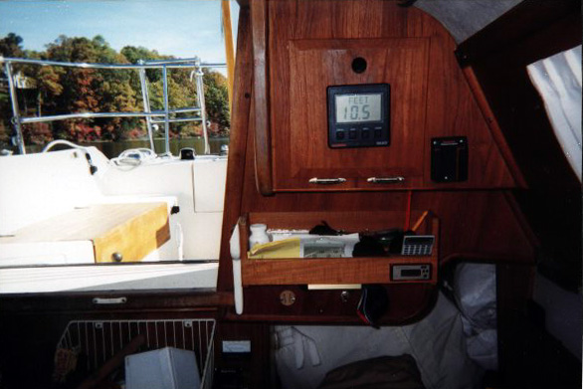
Instrument Repeater
An Autohelm Multifunction instrument display is located on instrument pod above the chart table. This instrument allows the navigator to monitor any of the deck instruments from below. The navigator can also use this repeater to display computed results from more than one instrument (e.g., VMG, true wind direction/speed, etc.). Refer to the Autohelm manual for the detailed operating procedures for this instrument.

VHF Radios
The Standard Horizon Quest+ VHF radio is located on the electronics panel outboard of the chart table. This is linked to a full function remote mic (RAM) in the cockpit. Refer to the manual for operations procedures. A second floating Icom handheld is located on the port side of the cabin entrance wall for quick access and is recommended to be carried personaly when single handing.

  - GPS – Garmin

We have a free-standing Garmin GPS system with maps for the Chesapeake Bay, it is located on a swing arm on the starboard side of the hatch way. Manuals are available on the site as well as onboard for use of this system. The GPS is connected to the Horizon radio to allow for ER location when the distress call is engaged.

  - Chart Plotter #1 – RaspberryPI

Full Sail has a custom chart plotter which is an integration of FOSS software and COTS hardware. The base of the system is a Raspberry Pi 3 single board computer running a Debian release of Linux. This board supports Bluetooth, WIFI, USB, micro-SD memory for mass storage, Touch Screen input and contains 1GB of memory and an ARM quad core processor. The core software uses OpenCPN as its base with additional software for NEA 0183 routing as well as alarm systems.

OpenCPN supports the input from the USB interfaced GPS puck located behind the NAV panel as well as the Daisy2+ AIS receiver in the same location. The entire system is available to user devices via VNC clients which can be found for phones, Pads and laptops.

  - Chart Plotter # 2 – RaspberryPI

Like # 1 this plotter is both a full Chart plotter running OpenCPN with GPS and local WiFi although it has a large 13” screen and will act as either a chart plotter or an Open Media Server to deliver video and movies from local storage.

  - AIS

Full Sail has a dual channel AIS receiver supplied by Daisy2+ which provides full AIS information as to Name, speed, direction and location for all boats transmitting within a 30NM range. This data is shared with the chart plotter and provides electronic sight and warning during low visibility and anchorage conditions. It is also a good watchman for collision avoidance.

  - WIFI – Local

Full Sail has an onboard WIFI system which allows all systems on the boat to intercommunicate easily. The SID is Fullsail and the password is sailor. Because of this network and the VNC support on the Chart plotter system any device on the network with VNC client may take control on the onboard system.

The local WIFI is capable of streaming Music and Video from a USB memory stick plugged into the labeled USB port on the NAV panel for entertainment.

When the Long Range system connects to outside WIFI systems the onboard system will support full connections to the internet only limited by the outside WIFI it has connected to.

  - WIFI – Long range

The Long Range WIFI has capability of connections up to 5NM range and typically is used to connect to known locations such as marina or known network providers. It is currently configured to connect to XFINITY networks as they are found.

Stereo

A Sony CD/AM/FM stereo is mounted on the electronics panel next to the VHF radio. There are four speakers connected to the stereo, two on each side of the main cabin behind the settees. The stereo is connected to a Sony 40Amp power amplifier mounted on the aft side of the bulkhead aft of the electronics panel. Refer to the Sony manual for operating procedures. The Stereo supports Bluetooth connections and can be linked to cell phones and used as a “CAR” type of handsfree operation.

Interconnection drawing to come

