Mooring & Docking in Hurricane Force Conditions

Note: Hurricane Season is June 1st thru November 1st in on East coast USA. Do not stay with boat if it is docked. 50% of injuries occur due to people heading for harbor from water or transporting on road during a storm.

Tasks become particularly more difficult in when wind speeds reach 20 knots. Typically surges can bring a maximum of 6-8 feet of raised tide.

Preparation
- Clear everything off deck and put it in cabin or take off boat completely.
- Lower sails completely, and tie up roller furling jib or consider dropping it completely. These almost always unfurl during a hurricane even if tied. If this is not an option, lash down everything completely multiple times.
- Consider using a messenger line to run all halyards up the mast so only one line remains exposed. As a last resort, lash halyards completely to the stanchion base and lash lines to mast to minimize drag and flapping of lines.
- Seal off every vent, cover, and closed hatch with plywood, plastic, or duct tape.
- Reduce windage (drag) by any means around the exterior of the boat (i.e. remove dodger)
- Plug all thru holes on boat, except for bilge pump outlet. All non-drainage seacocks should be closed and the exhaust outlet sealed to save the engine. Make a note over instrument panel to remember to undo these tasks before restarting the engine again.
- Verify that batteries are charged up and all electrical equipment is off except for bilge. Verify bilge is in operating order and not clogged.
- Close fuel tank, turn fuel off to engine, and close any propane or alcohol stoves.
- Remove any electronics from the boat if possible, or seal them in compartments.
- Remove all books and paper from the boat, or seal them in water tight compartments. These can clog the bilge.
- Check any leftover place where water could get into boat, and seal it.
- Photograph everything in event of insurance claim.

Hauling and Storing Ashore: (statistically ideal)
- Verify quality of cleats and deck hardware. Boat will still need to be tied down, as boat yards are still near water level. Ideally put on trailer and transport to higher ground.
- Ideally remove mast. Leaving it in is an invitation for disaster.
- Use additional jack stands, and chain them together.
- Consider using plywood to distribute load on boat from jack stand
- Use more jack stands that you normally would and chain them together. In addition, consider using plywood over top of the jack stand pads to distribute the load of the hull.
- Use additional lines to tie down anything that may be of value or hold to the boat that is not already well-secured.
- Get off of boat.

For Mooring (2nd safest):
- Verify quality of cleats and other deck hardware. Always be skeptical unless visually observed underwater with snorkel.
- Increase scope from normal ratio to 10:1, and double up on mooring lines. If using all chain rode, use a snubber line 10% of length of chain to absorb jerking. Distribute weight between cleats on the boat by tying each line to multiple cleats. 1 or 2 three turns around a winch before going to a cleat will better distribute load.
- Consider dropping largest anchor in direction of wind, and second largest 180 degrees from it, as far from the boat as possible.
- Verify significant swing between boat and other boats/objects
- If suitable mooring is not an option, drop 3 storm anchors 120 degrees apart joined by an oversized swivel
- Use Chaffing gear around side of boat. Leather around rope, garden hose, and plastic bags with duct tape will help also. Consider making 2’X3” webbing strips with Velcro on each side to use as chaffing guards. Anti-chaffing should anchor the ropes in one spot, not move with water level.
- If possible, get off of boat.

For Protected Waterway, Hurricane Hole, Inland Canal, or Backwater (3rd safest):
- Verify quality of cleats and other deck hardware
- Use 2 storm anchors, placed well away from boat 45 degrees away from shore. Tie off to trees and shore side approx. 45 degrees off of bow and stern. Use antichaffing gear.
- Try to place boat in center of waterway if possible.
- Verify there is enough scope to handle the surge.
- Verify water below boat is 2 or 3 times boats draft as wind can displace water.
- If no configuration above is possible, revert to Mooring step 4
- If possible, get off of boat.

For Docking (4th safest):
- Remove any water lines or power lines going to boat.
- Check quality of cleats, piling hoops, and pilings.
- Face boat towards open water to more easily take on waves
- Use lines about the length of the boat to permit tidal changes. Use chaffing gear to prevent ware.
- Use all available fenders.
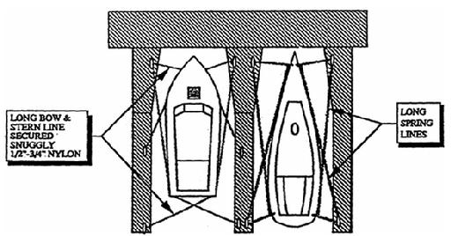
- Verify lines cannot slip off of top of pilings. Center boat in slip to avoid being impaled by pilings.
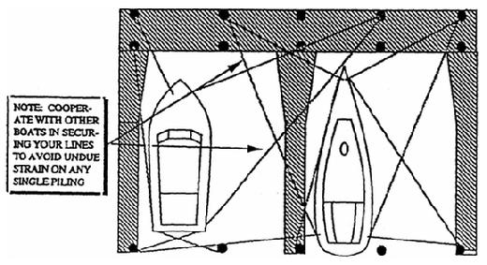
- Get off of boat.

NOTE: IT IS IMPORTANT TO UNDERSTAND THAT NOT ALL TIDE RISERS ARE STRUCTURALLY DESIGNED TO WITHSTAND LOADS FROM BOATS IN HIGH WINDS, AND MAY SEPARATE FROM THE PILING UNDER STRONG WIND LOAD. ALWAYS ASK YOUR MARINA WHAT TO SECURE THE LINES TO.

